PROJECT DOCUMENTATION
Soil Moisture Monitoring System
IoT-Based Water Level Indication using NodeMCU (ESP8266)

Project by PILLA JOSHI

  Soil Probe | 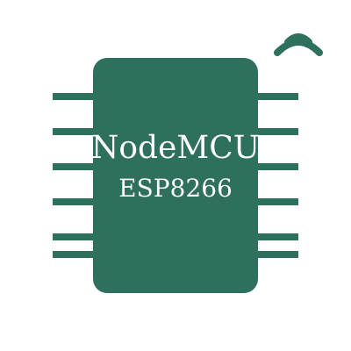  NodeMCU Control Unit | 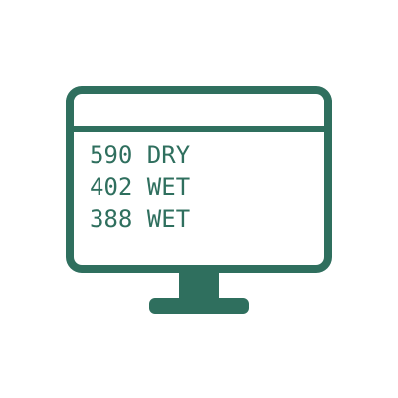  Serial Monitor

KEY COMPONENTS

  NodeMCU ESP8266 |   Soil Moisture Sensor |   Dual-Status LEDs |   Jumper Wires

1. Abstract
Water is the single largest consumable input in agriculture, and a significant fraction of it is wasted through irrigation that is scheduled by habit rather than by actual soil condition. Any system that can report, cheaply and continuously, whether the soil surrounding a plant's root zone is dry or adequately wet addresses this problem directly at its source.
This project implements such a system using the NodeMCU ESP8266 (ESP-12E) development board as the controller. A resistive soil moisture probe, conditioned by an LM393-based sensor module, is connected to the board's single analog input channel. The firmware samples this channel once per second, compares the resulting 10-bit value against a fixed calibration threshold, and drives one of two indicator LEDs accordingly — green for adequate moisture and red for a dry-soil condition. In parallel, every raw reading and its interpreted status are transmitted over the UART interface at 115200 baud, where they can be observed on the Arduino IDE serial monitor for verification, logging and threshold tuning.
The completed system was tested under both dry and moist conditions. Dry readings clustered in the 590–593 range and wet readings in the 378–403 range, placing both states firmly on either side of the 512 threshold and confirming that the chosen decision boundary is well separated from the noise floor. The project demonstrates a complete embedded control loop — analog acquisition, digital decision making, physical actuation and serial telemetry — and forms a directly extensible base for a networked, fully automated irrigation controller.

2. Introduction
Every embedded system, regardless of complexity, is built on the same underlying cycle: sense the physical world, process the measurement, and act on the result. This project is a deliberately compact realisation of that cycle, chosen because each stage is visible and individually verifiable.
Soil moisture is a useful physical quantity to work with for two reasons. First, it is genuinely slow-moving — it changes over minutes and hours rather than milliseconds — so a one-second sampling rate is more than sufficient and the system's behaviour can be observed comfortably in real time. Second, it can be manipulated at will during testing simply by moving the probe between dry air and moist soil, which makes verification straightforward without any specialised test equipment.
The ESP8266 was selected over a conventional AVR-based Arduino board for a specific reason: it carries an integrated 802.11 b/g/n Wi-Fi radio on the same die as the microcontroller. Although this project does not use the radio, its presence means the entire system can be upgraded from a standalone indicator to a cloud-connected sensor node purely through firmware changes, with no alteration to the hardware whatsoever. This makes the design a genuine stepping stone rather than a dead-end demonstration.

3. Objectives
- Acquire a continuous, repeatable analog measurement of soil moisture using a resistive probe connected to the ESP8266's ADC.
- Convert the raw 10-bit ADC value into a meaningful binary decision using a calibrated comparison threshold.
- Provide immediate, unambiguous local visual feedback through two mutually exclusive status LEDs.
- Stream live sensor data over the UART interface so that readings can be monitored, logged and used to recalibrate the threshold for different soil types.
- Verify correct operation experimentally under both dry and wet conditions and document the measured value ranges.
- Establish a hardware and firmware foundation that can later be extended to Wi-Fi telemetry or automatic pump control without redesign.

4. System Block Diagram
The system is organised as a linear signal chain with three parallel output paths. The soil probe converts a chemical/physical property of the soil into an electrical resistance; the sensor module converts that resistance into a proportional voltage; the microcontroller digitises that voltage, applies a decision rule, and fans the result out to three destinations — two LED indicators and the serial port.
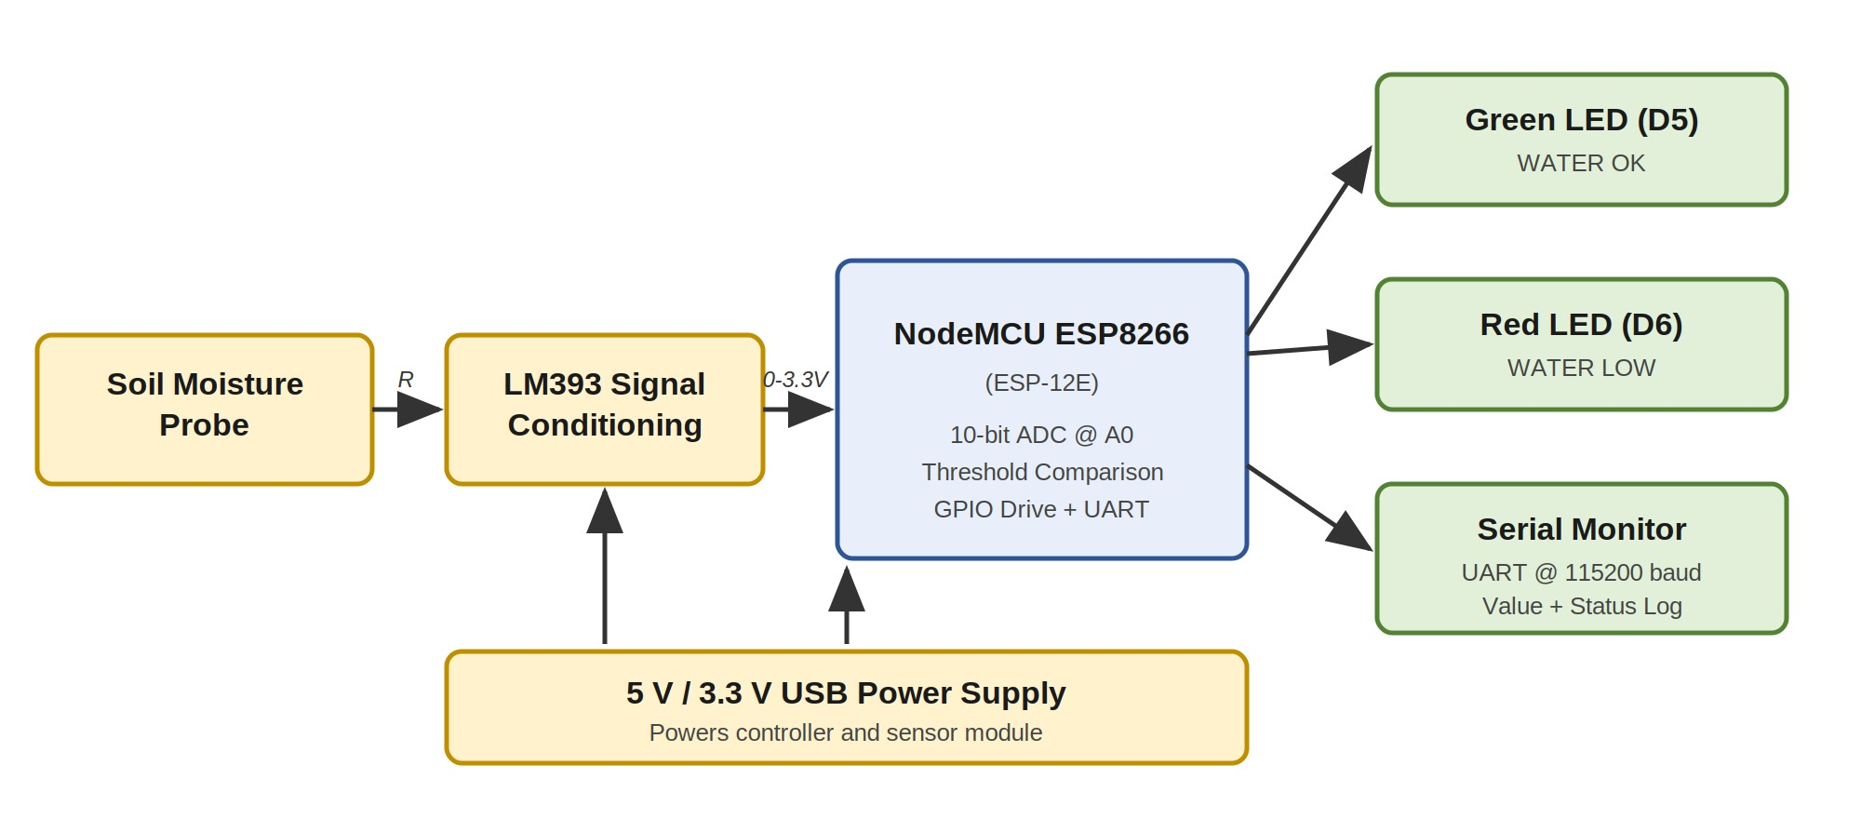
Figure 1 — System block diagram showing the sensing, conditioning, processing and output stages.

4.1 Stage-by-Stage Description
Sensing stage: The resistive probe consists of two parallel conductive traces inserted into the soil. The soil between them completes a circuit whose resistance depends on the concentration of dissolved ions and free water. Wet soil conducts well and presents a low resistance; dry soil conducts poorly and presents a high resistance.
Signal conditioning stage: The LM393-based sensor module places the probe in a potential divider network against a fixed reference resistance, converting the variable resistance into a variable voltage on the analog output pin. The module is powered from the board's regulated supply and produces an output that swings across the usable input range of the ADC.
Processing stage: The NodeMCU samples this voltage through its 10-bit successive-approximation ADC, producing an integer between 0 and 1023. The firmware compares this integer against the threshold constant and selects one of two mutually exclusive output states.
Output stage: The two GPIO pins D5 and D6 drive the green and red LEDs respectively through current-limiting resistors. Simultaneously, the UART transmitter pushes the raw value and the textual status to the host PC over the same USB cable used for power and programming.

5. Hardware Requirements
Component | Specification | Purpose in this Project
NodeMCU ESP8266 | ESP-12E module, 80 MHz Tensilica L106, 3.3 V logic, on-board CP2102/CH340 USB-UART | Main controller: ADC sampling, decision logic, GPIO drive, serial output
Soil Moisture Sensor | Resistive two-prong probe with LM393 comparator breakout, analog + digital outputs | Converts soil conductivity into a proportional analog voltage
Green LED | 5 mm diffused, ~2.0 V forward drop, 20 mA nominal | Indicates the WATER OK (sufficient moisture) state
Red LED | 5 mm diffused, ~1.8 V forward drop, 20 mA nominal | Indicates the WATER LOW (dry soil) state
Resistors | 220 Ω to 330 Ω, ¼ W, two required | Limit LED forward current to a safe level for both the LED and the GPIO pin
Jumper Wires | Male-to-male and male-to-female, assorted | Interconnection between board, sensor and LEDs
USB Cable | Micro-USB, data-capable (not charge-only) | Supplies 5 V power and carries the programming / serial link
Host Computer | Any PC with a free USB port | Compilation, firmware upload and serial monitoring

5.1 Why These Component Values
The current-limiting resistor value is derived from the supply rail, the LED forward drop and the desired current. With a 3.3 V GPIO output and a green LED dropping roughly 2.0 V, the resistor sees about 1.3 V across it. A 220 Ω resistor therefore passes approximately 6 mA — comfortably visible for an indoor indicator, and far below the roughly 12 mA per-pin limit of the ESP8266 GPIO, which protects the microcontroller from damage. Using 330 Ω reduces this further to about 4 mA, which is still clearly visible and gives an even larger safety margin.

6. Software Requirements
Item | Configuration Used
Development environment | Arduino IDE with the ESP8266 core installed through Boards Manager
Board selection | NodeMCU 1.0 (ESP-12E Module)
CPU frequency | 80 MHz (default)
Flash size | 4 MB (FS: 2 MB, OTA: ~1019 KB) — default
Upload speed | 115200 baud
Serial port | COM3 (as enumerated during testing)
Serial monitor baud rate | 115200 baud
Additional libraries | None — the sketch uses only core Arduino functions

An important practical note: the serial monitor baud rate must match the rate set in the firmware. If the two differ, the monitor displays unreadable characters rather than the expected readings, which is one of the most common sources of confusion when bringing up a new ESP8266 sketch.

7. Pin Configuration and Circuit Connections
Signal | NodeMCU Label | GPIO | Direction | Notes
Soil sensor analog output | A0 | ADC0 | Input | Only ADC channel
Green status LED | D5 | GPIO14 | Output | Active HIGH
Red status LED | D6 | GPIO12 | Output | Active HIGH
Sensor supply | 3V3 | — | Power | 3.3 V rail
Common ground | GND | — | Reference | Shared by all

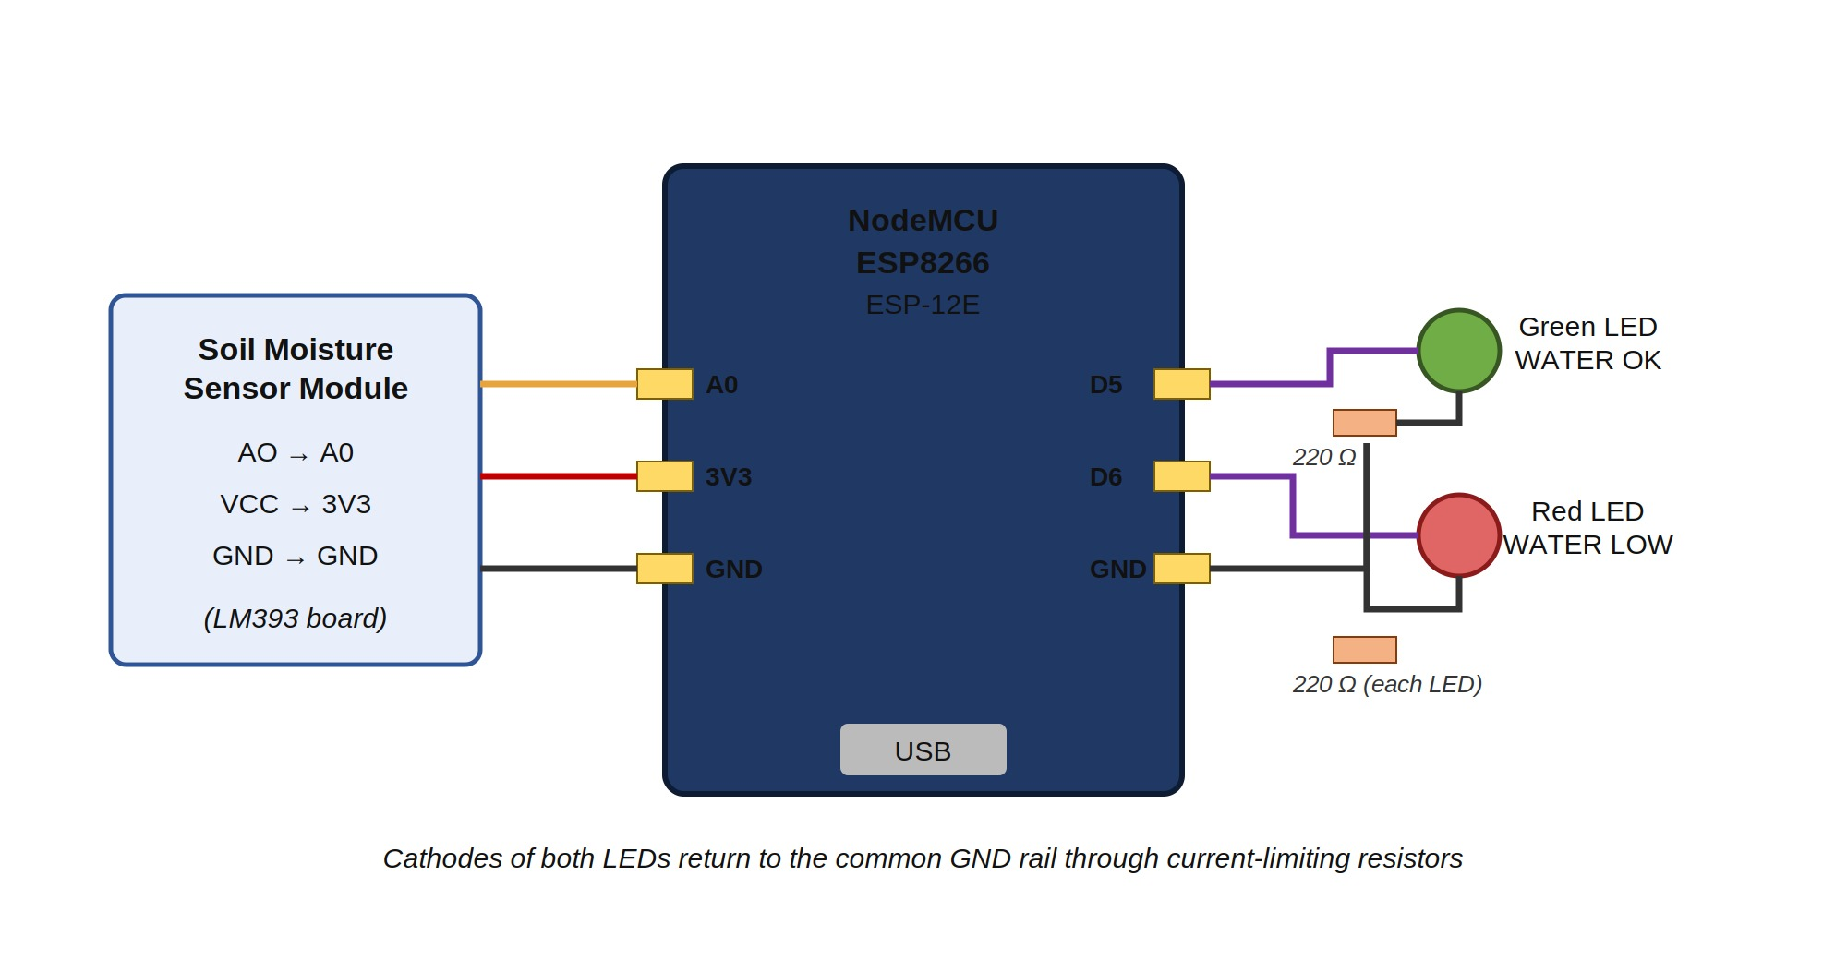
Figure 2 — Circuit connection diagram showing sensor, controller and LED wiring.

7.1 A Note on the ESP8266 Analog Input
The ESP8266 chip itself accepts only 0 to 1.0 V on its ADC pin — applying more than this can permanently damage the input. The NodeMCU development board solves this by fitting an on-board resistive divider between the A0 header pin and the chip, which scales the usable input range to approximately 0 to 3.3 V. This is why the sensor module's analog output can be wired directly to A0 on a NodeMCU board, and also why the same sensor must never be connected directly to a bare ESP-12E module without adding an external divider.

7.2 Choice of D5 and D6
Not every GPIO on the ESP8266 is free to use as a general-purpose output. Several pins are tied to the boot-mode strapping logic and will prevent the board from starting correctly if they are pulled to the wrong level at power-up. D5 (GPIO14) and D6 (GPIO12) carry no such restriction, are physically adjacent on the header, and have no alternate-function conflicts in this design — which makes them the natural choice for simple LED indicators.

8. Working Principle
The operating principle rests on a simple physical fact: the electrical conductivity of soil rises sharply with its water content, because water dissolves mineral salts into mobile ions that carry current between the probe's electrodes.
When the soil is dry, there are few mobile ions, the path between the probe electrodes is highly resistive, and the potential divider on the sensor module holds its analog output near the upper end of the supply range. The ADC therefore reports a high count. When the soil is wet, the same path becomes far less resistive, the divider output is pulled down, and the ADC reports a low count. The relationship is inverse: a higher number means drier soil.

8.1 Firmware Execution Sequence
On power-up the firmware performs a one-time initialisation: it opens the serial port at 115200 baud, configures D5 and D6 as outputs, and drives both LEDs low so the system starts from a known, unambiguous state rather than from whatever level the pins happened to float to.
It then enters a continuous loop that repeats once per second and performs four actions in order:
- Sample — the analog voltage on A0 is digitised into an integer in the 0–1023 range.
- Report — the raw integer is transmitted over the serial port with a descriptive label, so the operator can see the actual measurement rather than only the derived verdict.
- Decide — the integer is compared against the threshold constant, fixed at 512, which is the exact midpoint of the ADC's output range.
- Actuate — if the value exceeds the threshold the soil is dry: the red LED is driven HIGH, the green LED LOW, and 'WATER LOW' is appended to the serial line. Otherwise the green LED is driven HIGH, the red LED LOW, and 'WATER OK' is appended.
A one-second delay closes the loop. This interval is deliberately chosen: it is far faster than soil moisture can meaningfully change, yet slow enough that the serial log remains human-readable and the LEDs do not flicker distractingly.
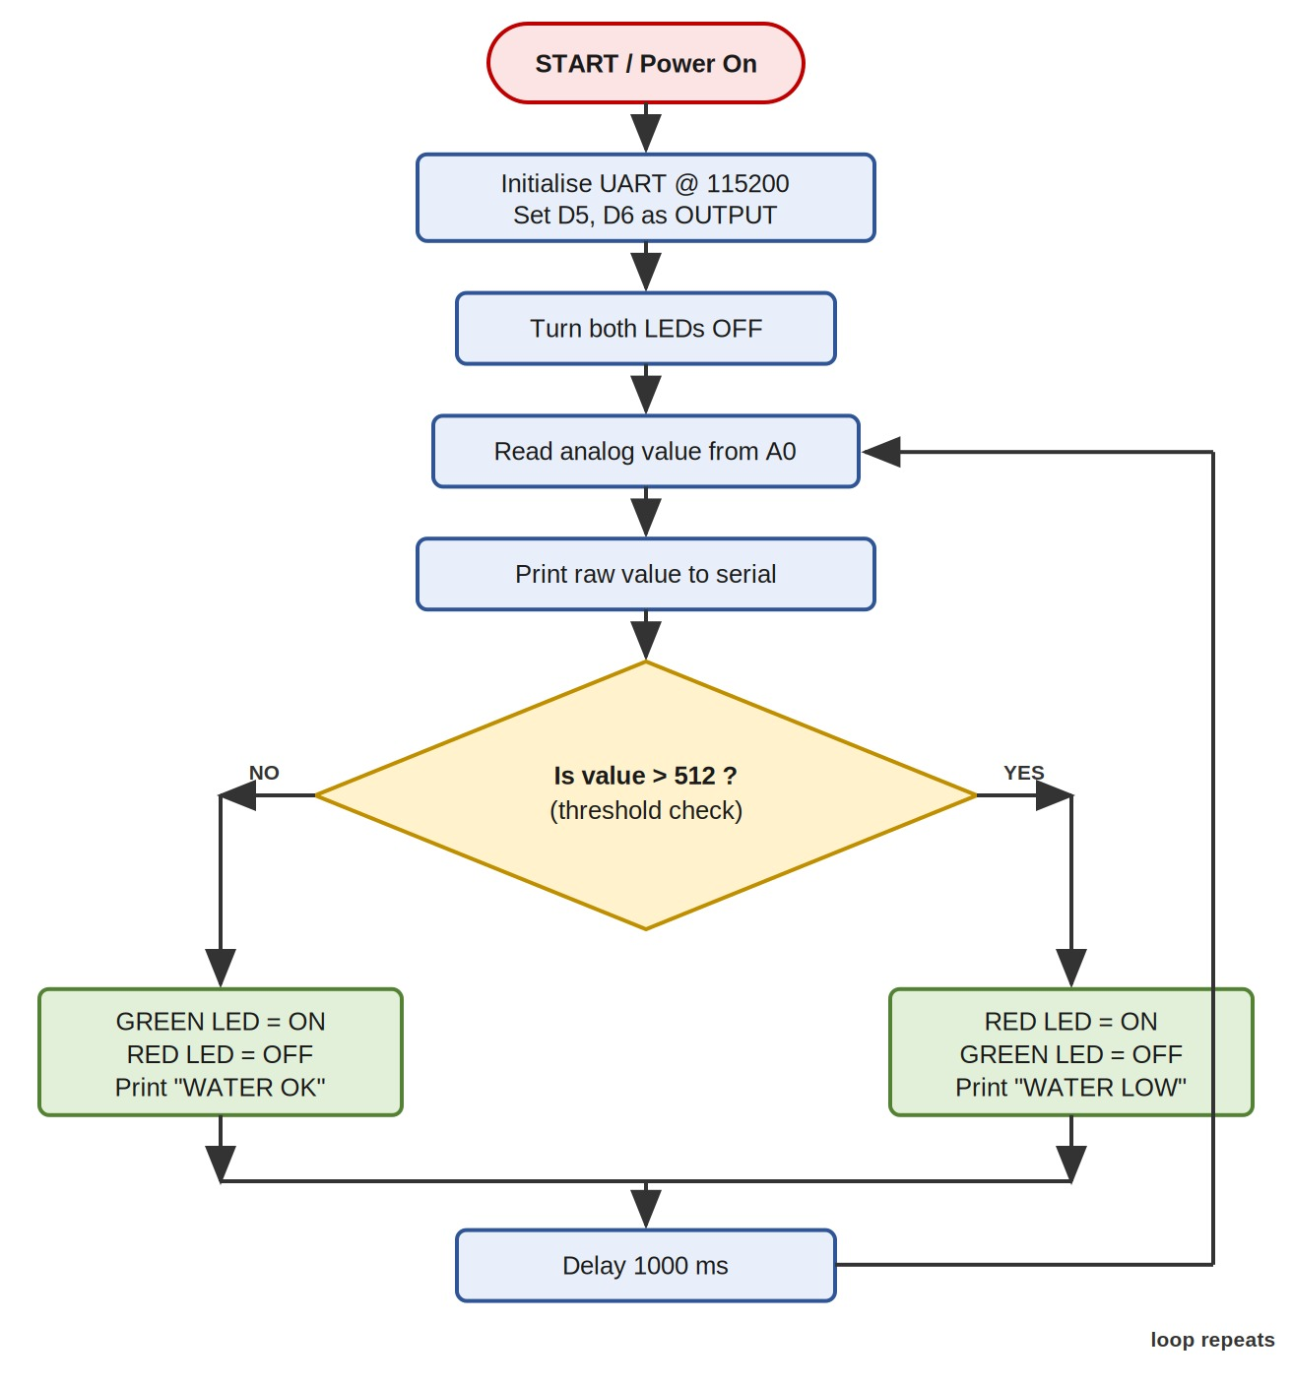
Figure 3 — Firmware flowchart showing initialisation and the repeating sense-decide-actuate loop.

9. Threshold Logic and Calibration
The threshold is the single most important tunable parameter in the entire system, because it alone determines where the boundary between 'wet enough' and 'too dry' is drawn.
ADC Range | Approx. Voltage | Soil Condition | Green LED | Red LED | Serial Output
0 – 512 | 0 – 1.65 V | Wet / sufficient | ON | OFF | WATER OK
513 – 1023 | 1.66 – 3.3 V | Dry / insufficient | OFF | ON | WATER LOW

9.1 Why 512 Was Chosen
A 10-bit ADC produces values from 0 to 1023, so 512 is its exact midpoint. Choosing the midpoint is the sensible default starting point when the probe's behaviour in a particular soil is not yet characterised, because it makes no assumption in either direction. The test results below justify the choice after the fact: the dry cluster sits about 80 counts above it and the wet cluster about 110 counts below it, meaning the threshold falls into a wide empty band with no measurements anywhere near it.

9.2 Field Calibration Procedure
For deployment in a specific soil, the threshold should be determined empirically rather than assumed. The recommended procedure is:
- Insert the probe into thoroughly dry soil of the target type, run the sketch, and record the steady serial reading. This is the dry reference.
- Water the same soil to the moisture level considered ideal for the plant, allow it to settle for several minutes, and record the new steady reading. This is the wet reference.
- Set the threshold to the midpoint between the two references, then update the constant in the firmware and re-flash.
- Verify by cycling the probe between the two conditions several times and confirming that the indication switches cleanly each time.

9.3 Factors That Affect Calibration
Several variables shift the readings and mean that a threshold calibrated in one situation may not transfer to another. Soil composition matters most — clay retains water and dissolved salts far better than sand, so the same water content produces different conductivity. Fertiliser content raises ionic concentration and lowers the readings independently of water. Temperature affects ion mobility slightly. Probe insertion depth and the firmness of soil contact also change the effective contact area. Finally, supply voltage variation directly scales the divider output, so a board running from a weak USB source may read differently from one on a solid supply.

10. Testing and Results
The assembled circuit was tested on a NodeMCU 1.0 board connected over COM3 with the Arduino IDE serial monitor open at 115200 baud. The probe was cycled between dry conditions and moist soil, and the behaviour of both the LEDs and the serial log was recorded at each state.

10.1 Test Case 1 — Dry Condition (WATER LOW)
With the probe held in dry conditions, the analog reading settled and remained in the 590 to 593 range across successive samples. This is comfortably above the 512 threshold, so the controller correctly asserted the low-water indicator and appended the 'WATER LOW' status to every line of the serial log. The green LED remained fully off throughout.
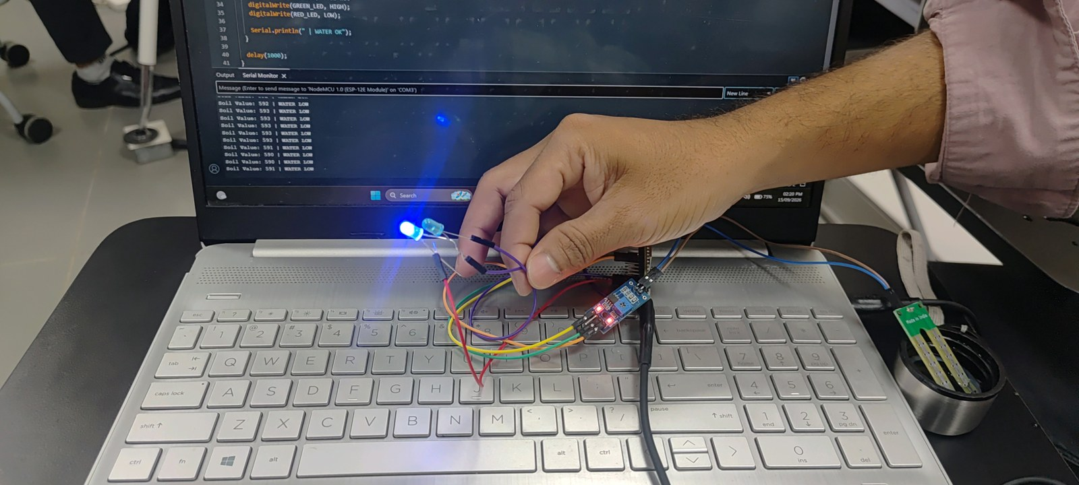
Figure 4 — Dry-soil test: readings of 590–593 exceed the threshold; low-water indicator active and the serial monitor logging 'WATER LOW' on every cycle.

10.2 Test Case 2 — Wet Condition (WATER OK)
The probe was then inserted into moist soil. The reading dropped promptly to the 378 to 403 range, falling clearly below the threshold. The green LED illuminated, the red indicator switched off, and the serial monitor changed to 'WATER OK'. The transition occurred on the very next sampling cycle after the probe was moved, confirming that the one-second loop delay is the only latency present in the system.
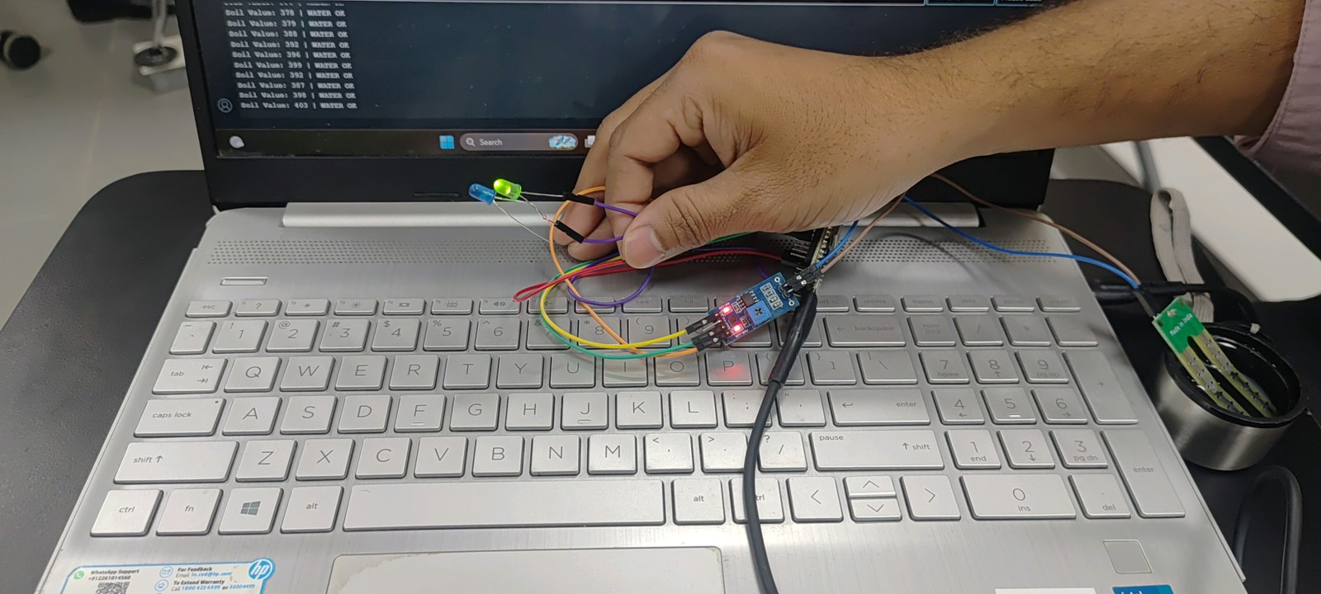
Figure 5 — Moist-soil test: readings of 378–403 fall below the threshold; green LED ON and the serial monitor logging 'WATER OK'.

10.3 Consolidated Results
Test Condition | Observed ADC Range | Margin from Threshold | LED State | Serial Status
Dry soil / air | 590 – 593 | +78 to +81 counts | Red ON | WATER LOW
Moist soil | 378 – 403 | −109 to −134 counts | Green ON | WATER OK

10.4 Observations and Analysis
- Readings were stable within roughly a ±3 count band in both states, indicating acceptable noise performance without any software filtering or averaging.
- The separation between the two clusters is approximately 190 counts — nearly one fifth of the full ADC range. This large gap means the system is not sensitive to small calibration errors.
- State transitions occurred on the next sampling cycle after the probe was moved, confirming there is no hidden latency beyond the deliberate one-second delay.
- Only one LED was ever illuminated at a time, verifying that the mutually exclusive drive logic behaves exactly as intended with no overlap or momentary double-on condition.
- The status text printed on each serial line always agreed with the LED that was lit, confirming that the indication and the telemetry are driven from the same decision and cannot diverge.

11. Advantages
- Very low component count and cost, making the design well suited to classroom demonstration and field prototyping alike.
- Instant local status indication without requiring a display, smartphone application or network connection of any kind.
- Continuous serial logging exposes the raw measurement, which allows the threshold to be recalibrated for any soil type without guesswork.
- Built on the ESP8266, so Wi-Fi connectivity is already present and can be enabled entirely in firmware with no hardware modification.
- Powered directly from the USB connection used for programming, so no separate power supply is needed during development.
- The firmware uses only core Arduino functions and no external libraries, which keeps it portable and free of dependency issues.

12. Limitations
- Resistive probes corrode over time under continuous DC excitation, as electrolysis gradually erodes the electrode plating. Capacitive probes are preferred for long-term deployment.
- The single fixed threshold includes no hysteresis, so a reading sitting exactly at the boundary can cause the indication to toggle between states on successive samples.
- The ESP8266 provides only one ADC channel, so monitoring multiple plants or depths requires an external analog multiplexer or a separate ADC chip.
- The output is a relative, calibration-dependent verdict rather than an absolute volumetric water content percentage.
- Readings are affected by fertiliser concentration and supply voltage variation, neither of which the current firmware compensates for.
- There is no data persistence — if the host PC is disconnected, the readings are lost.

13. Future Enhancements
- Add software hysteresis by using two separate thresholds — one for switching to dry and a slightly lower one for switching back to wet — which eliminates boundary flicker entirely.
- Average several consecutive samples before comparison to further suppress electrical noise and transient spikes.
- Drive a relay or MOSFET module to switch an irrigation pump automatically when the soil is detected as dry, closing the control loop.
- Publish readings over Wi-Fi using MQTT or HTTP to a cloud dashboard such as ThingSpeak or Blynk, enabling remote monitoring and historical charting.
- Power the probe from a GPIO pin and energise it only during the moment of measurement, which dramatically reduces electrode corrosion and extends probe life.
- Add a DHT22 sensor to correlate soil moisture with ambient temperature and humidity for better irrigation decisions.
- Migrate to a capacitive probe for improved long-term stability and immunity to electrode degradation.

14. Conclusion
The soil moisture monitoring system was successfully designed, assembled, programmed and tested. Under experimental verification the firmware reliably distinguished between dry and moist conditions, with measured values of 590–593 in the dry state and 378–403 in the wet state — both falling clearly on the correct side of the 512 threshold with a wide separating margin. The dual-LED indication and the serial telemetry agreed with each other in every observed case.
Beyond the immediate result, the project demonstrates a complete and correctly structured embedded sensing loop: analog acquisition through the ADC, threshold-based decision making in firmware, digital actuation through GPIO, and status reporting over UART. Each of these stages is a building block that recurs in almost every embedded product, which makes the exercise valuable well beyond its specific application. The choice of the ESP8266 platform further means that the step from this standalone indicator to a networked, automated irrigation controller requires only firmware development, with the existing hardware carried forward unchanged.

